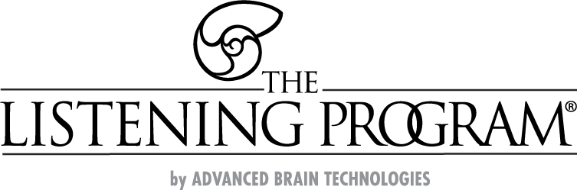

Advanced Brain Technologies program information for physicians serving TRICARE ECHO Families

Advanced Brain Technologies (ABT) programs offer drug-free and non-invasive methods intended to benefit children, teens, and adults with special needs. Each evidence-based therapeutic program is used in the individual’s home to aid in a better quality of living.

Using The Listening Program (TLP) method of music listening therapy to support clinical treatments will provide a solid foundation for long-lasting rehabilitation and intervention outcomes.

Each program supports specific areas of need while emphasizing improved sensory processing, self-regulation, learning, communication, motor coordination, emotional regulation, behavior, relaxation, mental acuity, or sleep management.

TRICARE ECHO Coverage

- Patients may receive up to 100% funding coverage for ABT products and therapy sessions through TRICARE ECHO.

- Active duty service members with dependents, including spouses that have been diagnosed with a mental, learning or physical disability are eligible for ABT Intervention coverage under the TRICARE ECHO program.

- Advanced Brain Technologies is an approved DME (durable medical equipment) supplier with TRICARE insurance. TRICARE is the insurance used by all branches of active duty military members and the Coast Guard.

Advanced Brain Technologies Ph. 888-228-1798 | advancedbrain.com/military
Or contact a TRICARE network provider

Available Programs

TLP SPECTRUM - Helps individuals to find comfort in their environment through improved sensory & emotional regulation, calming, and supporting development of fine & gross motor skills.

TLP ACHIEVE - Intended to support improved memory, learning & communication skills as well as refine executive thinking and decision making.

TLP LEVEL ONE - Offers advanced listening training to build upon the focus areas of SPECTRUM and ACHIEVE to continue the development of and maintain benefits.

TLP inTime - Stimulates focus, adaptive responses to stress and increased brain-body connection using rhythmic music listening therapy with adaptive movement activities incorporating the body, drum and voice.

Waves Bone Conduction headphone system - Supports calming and accelerates the benefits of music listening therapies which require high-quality headphones by using the two natural modes of hearing – through your ears (air conduction) and through your body (bone conduction).

Sennheiser HD 558 Headphones - Approved air conduction headphones for use with ABT music listening therapies.

Sleep Genius - Sound-based sleep aid with music and neurosensory sounds for sleep management.

BrainBuilder - Improve working memory, attention, visual/auditory processing speed and problem solving skills with this PC-based, cognitive training program.

Sound Health & Music for Babies - Specialized classical music recordings intended to support therapeutic interventions for improved concentration, thinking, relaxation and learning.

